# Department of Computing

**CS471: Machine Learning**

**Class: BESE-7AB**

**Lab 10: Model Evaluation**

**C5: Use modern tools to solve practical problems.**

**Date: 19-04-2019**

**Time: 10:00 am–1:00 pm & 2:00 pm-5:00 pm**

**Instructor: Dr. Pakeeza Akram**

**Name: Nimra**

**Class: BESE-7B**

**Registration No.199281**

**Lab 10: Model Evaluation**

**Introduction**

In this lab you will assess some of the algorithms that you have used and developed in previous labs.

**Objective**

Practically implement assessment methods for model evaluation

**Tools/Software Requirement**

Python, numpy

**Tasks**

Recall labs 5,7 and 9 in which you applied decision trees, naïve Bayes and ANN on IMDB dataset. For each of those algorithms calculate the following:

1. Accuracy
2. Precision
3. Recall
4. Sensitivity
5. F-score

**Deliverables:**

* Notebook file along with Word File with all codes and screen shots of results.

**ScreenShots**

**Lab5**

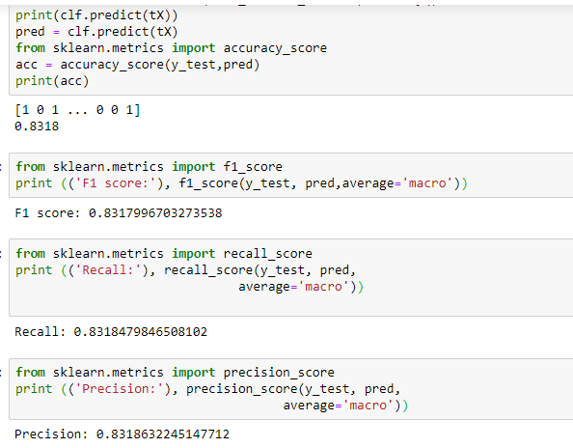

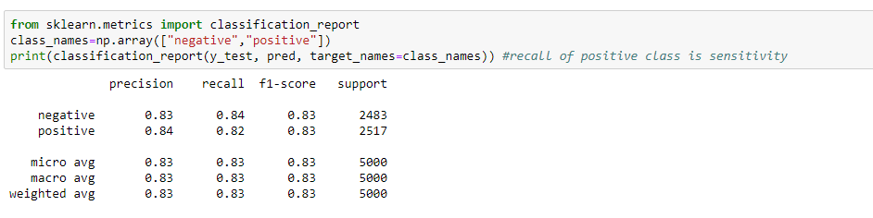

**Lab7**

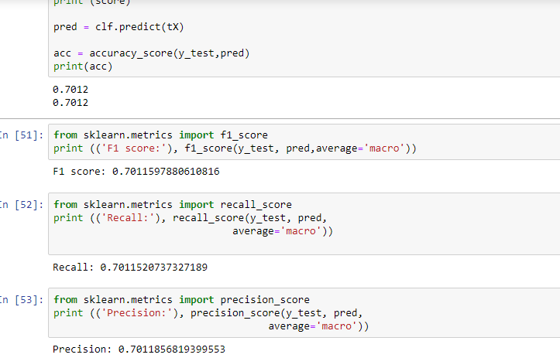

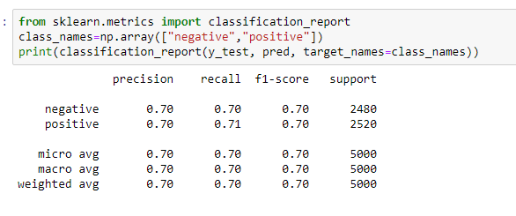

**Lab09**

For Alpha 0.00001 and features 3000

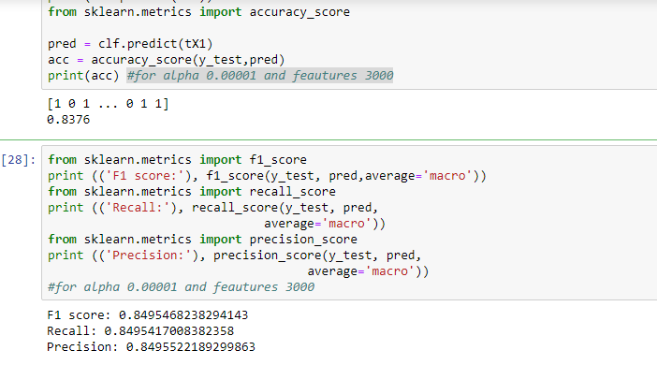

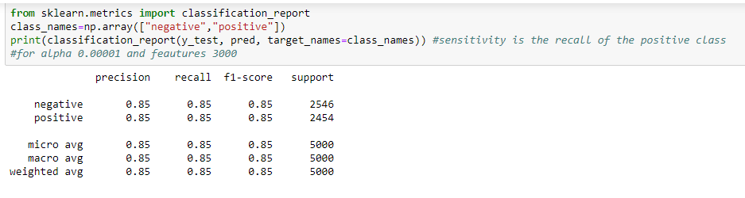

For Alpha 5 and features 3000

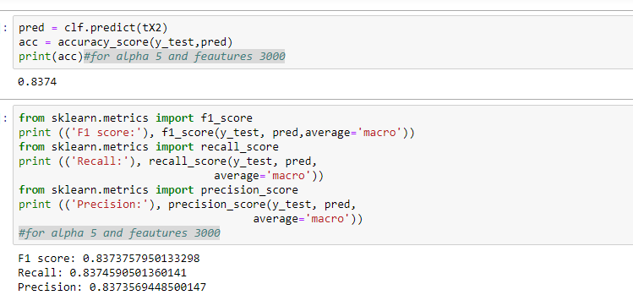

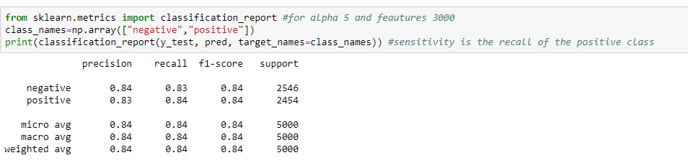

For Alpha 0.00001 and features 5000

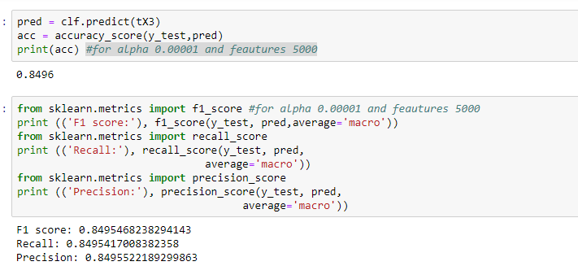

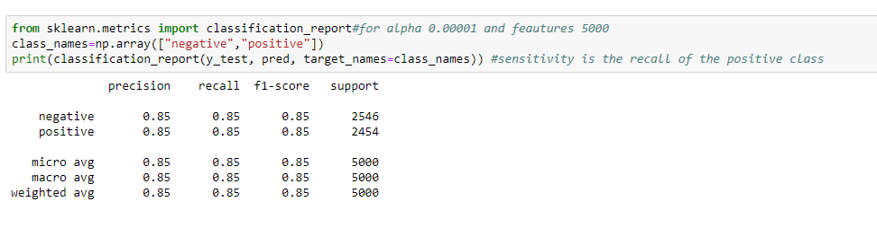

For Alpha 5 and features 5000

